The administrator of your Moodle site (which must be version 2.4 or later) must enable mobile access as follows:

* First, in Site administration > Advanced features, tick the enable Web Services checkbox, then
* In *Site administration > Plugins > Web services > Mobile* tick the 'Enable web services for mobile devices' checkbox, then click the button to save changes.

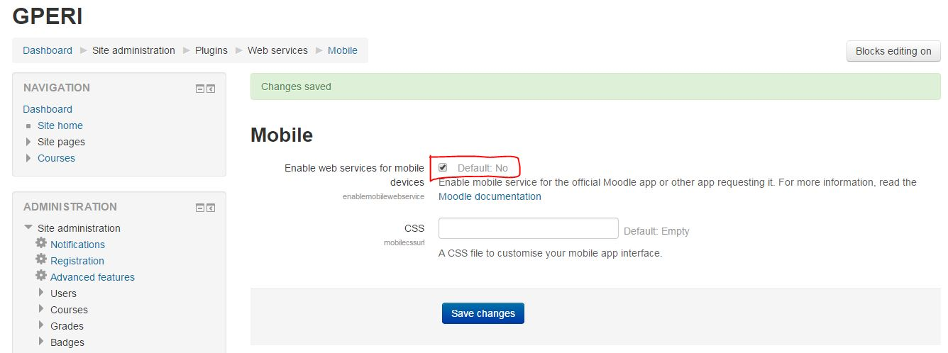

Now you must Install Moodle Attendance Plugin on your moodle system to do so first you need to download Moodle Attendance Plugin File (mod_attendance_moodle29_2015040500.zip) and install it as shown bellow  
  
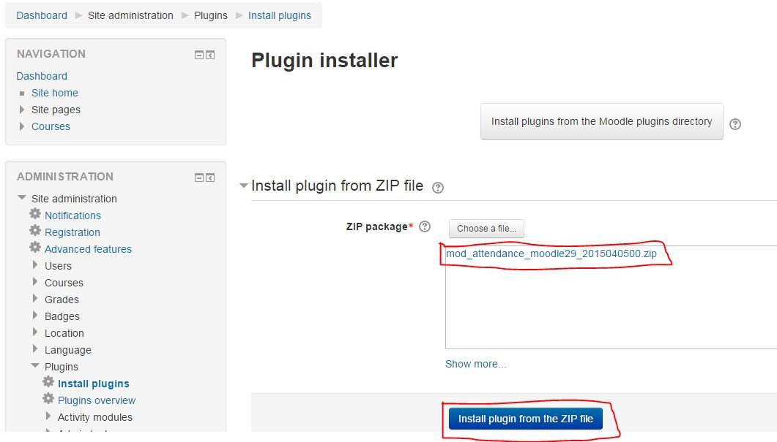

Now you should see the plugin in the Plugins Overview Page as bellow  
  
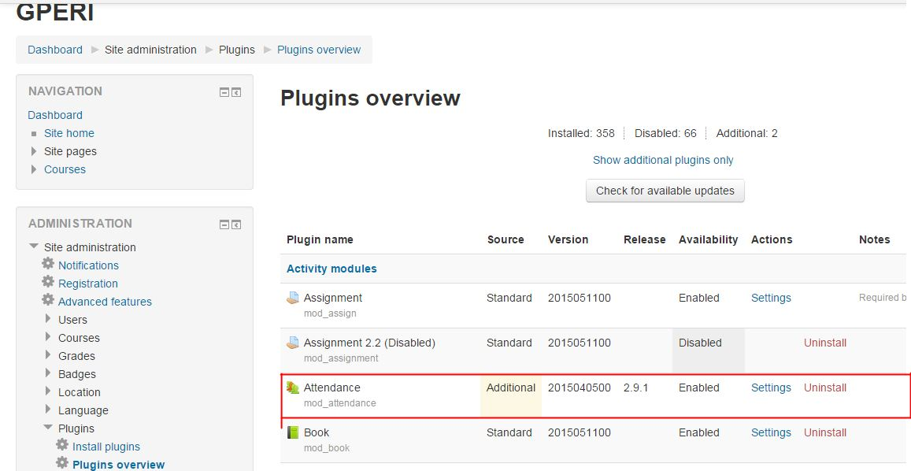  
The last and the important thing, You must change moodle config.php file as follows  
  
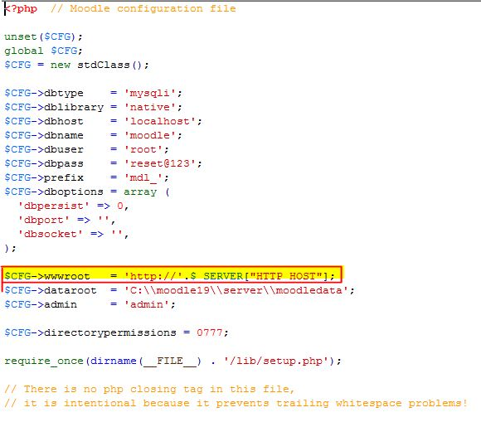  
Change **$CFG->wwwroot** value  
  
if you have following value:  
**$CFG->wwwroot = 'http://localhost';** or **$CFG->wwwroot = 'http://yourwebsite';**  
change it to:  
**$CFG->wwwroot = 'http://'.$_SERVER["HTTP_HOST"];**

if you have following value:  
**$CFG->wwwroot = 'http://localhost/moodle';** or **$CFG->wwwroot = 'http://yourwebsite/moodle';**  
change it to:  
**$CFG->wwwroot = 'http://'.$_SERVER["HTTP_HOST"].'/moodle';**